library@hud.ac.uk
July 2023
EndNote 20
Introduction to the desktop version
Table of contents
Section 1: Introduction 3
Section 2: Installing/ accessing EndNote 3
2.1 Installing EndNote 20 on my home device or personal University laptop 3
2.2 Accessing EndNote 20 on a University networked PC 3
Section 3: Setting up your EndNote desktop 3
Exercise 1: Creating an EndNote library 3
3.1 5
Exercise 2: Creating a backup with EndNote Online 5
Tips: 7
3.2 Importing references into your Library 7
Exercise 1: Adding references from Summon 7
Tip 8
Exercise 2: Adding references from Scopus 8
3.3 Amending and manually adding references 9
3.4 Manually add a reference 10
Exercise 4: Manually adding a reference 10
Tips: 11
Section 4: Changing a referencing style 11
Exercise 5: Change reference style to APA 7th 11
Section 5: Using groups to organise references 12
Exercise 6: Creating groups 12
Tips 12
Section 6: Using EndNote and Word 12
6.1 Adding citations and formatting a bibliography 13
Exercise 7: Adding citations and formatting a bibliography in Word 13
Tips: 14
6.2: Editing citations in Word 14
Exercise 8a: Adding page numbers to your citation 14
Exercise 8b: Excluding author/year from your citation 15
Tips: 15
Section 7: Managing PDFs and attachments in EndNote 15
Exercise 9a: Downloading a PDF into EndNote 15
Exercise 9b: Adding a PDF to a reference 16
Exercise 9c: Extract reference from existing PDF 17
Tips: 18
Section 9: Saving, backing up and moving your EndNote Library 18
Tips: 19
Section 10: Where can I access EndNote? 19
Section 11: Further help 19

Section 1: Introduction
This guide provides an overview on using EndNote 20 software via the University of Huddersfield. There are various set up options to choose from, depending on whether your main device is your own or University owned. If you have any queries, please direct them to the librarians at library@hud.ac.uk

Section 2: Installing/ accessing EndNote
Follow the relevant section guidelines depending on your preferred working environment. We recommend all users create an EndNote Online account too (see 2.3), to have a backup copy in the cloud, hosted by Clarivate, the owners of EndNote.

2.1 Installing EndNote 20 on my home device or personal University laptop
You can get a free download of EndNote 20 on your home device or personal University laptop.
Go to the software download page and select EndNote 20 (Mac or Windows as preferred). You will be prompted for a login and password. The username is in the format u1234567 for students or cmsxabc for staff.
Open the zip folder and read the instructions for installation. This folder will also include a copy of this workbook!
2.2 Accessing EndNote 20 on a University networked PC
All networked PCs in the Library should have EndNote 20 installed. If the one you are using in your department doesn’t or has an older version of EndNote, please contact your local IT support (school or Library as appropriate).
You will find EndNote by clicking on the Windows button or using the search function, both in the bottom left of the screen.
This device you are using is a shared computer so you need to be aware of where you save your EndNote files. EndNote is not compatible with any cloud storage services, including SharePoint (UniShare), OneDrive, Box Sync, Google Drive, DropBox and iCloud, as the files may corrupt over time.

Section 3: Setting up your EndNote desktop
This section assists you in setting up your library in the desktop version and linking it to a backup version via EndNote Online.

Exercise 1: Creating an EndNote library
Open EndNote on your device.
If you have a previous library on your device (e.g. set up with EndNote X9) then it may open automatically.

Windows instructions:
If you are a Windows user you will be presented with this screen:
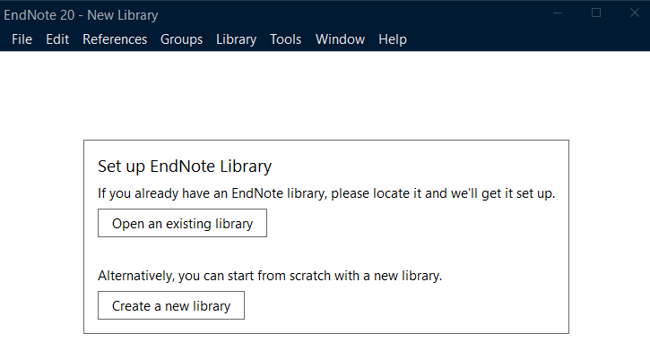
Select Open an existing library if you have an X9 file and it will prompt you to locate the file on your device. Please ensure to remove it from any cloud storage space, e.g. OneDrive.
Select Create a new library if you are new to EndNote. Do not save the file to OneDrive, Dropbox, or any other cloud storage service. EndNote files are not compatible with cloud storage and will corrupt over time.
Instead, please save the EndNote library file to the local hard drive. If you are on a university-owned computer, you will need to save to folder labelled with your username in the C: Drive. You will find this in C: > Users > [username]. You will need to set up an EndNote Online account to sync your library. Instructions for syncing your EndNote library are in Section 3.1 of this workbook.
If you are unsure, please contact IT Support for further advice on it.support@hud.ac.uk or phone 01484 473737.

Mac instructions:
If you are a Mac user you will be presented with an EndNote toolbar at the top of the screen.
Go to File. Select Open Library if you have an EndNote library. It will prompt you to locate the file on your device. Please ensure to remove it from any cloud storage space, e.g. OneDrive.
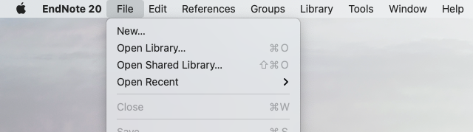
Do not save the file to iCloud, OneDrive, Dropbox, or any other cloud storage service. Instead, please save the EndNote library file to the local hard drive. You will need to set up an EndNote Online account to sync your library. Instructions for syncing your EndNote library are in Section 3.1 of this workbook.

The empty library looks like this:
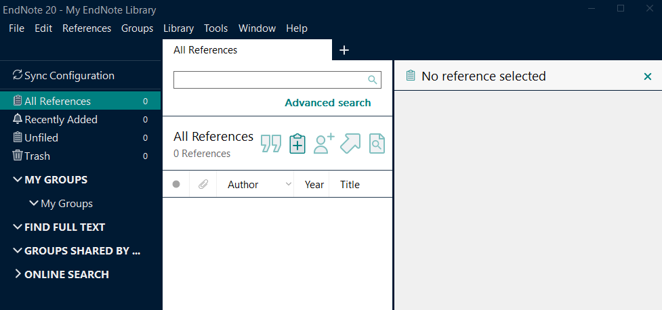
If you are unsure, please contact IT Support for further advice on it.support@hud.ac.uk or phone 01484 473737.
3.1 Creating an EndNote Online account to sync with desktop
We strongly recommend all users create an EndNote Online account to back up your account and allow you to access your library on multiple devices. The backup will be hosted by Clarivate, the owners of EndNote, in their own cloud storage. If you are using Endnote on a university computer, you need to set up an EndNote Online account to sync your library.
EndNote Online also allows you to share your library/ groups of your references with other EndNote users. This is useful if you are collaborating on research across the university or with external researchers.

Exercise 2: Creating a backup with EndNote Online
- Go to the EndNote Online registration page.
- Follow the instructions to register an account.
- Confirm the email notification to complete registration.
- Return to EndNote 20 desktop version.

Windows instructions:
- If you are a Windows user click on Edit from the top left-hand menu then Preferences.
- This pop-up box will appear:
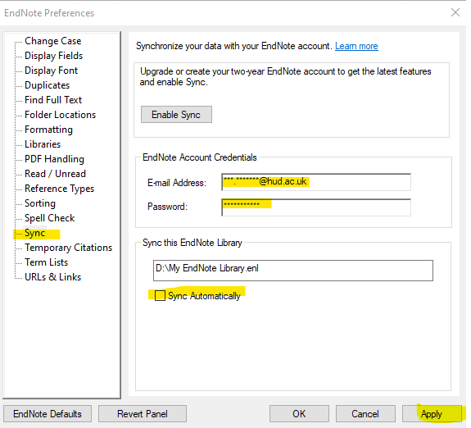
- Click on Sync from the left-hand menu.
- Type in the email and password you used for your EndNote Online account.
- Untick the Sync automatically box (we encourage you do this manually, every time you log off, because if not the library regularly syncs to the cloud and can slow down the performance of EndNote.)
- Click Apply to finish the set up.

Mac instructions:
- If you are a Mac user click on EndNote from the top left-hand menu then Preferences.
- This pop-up box will appear:
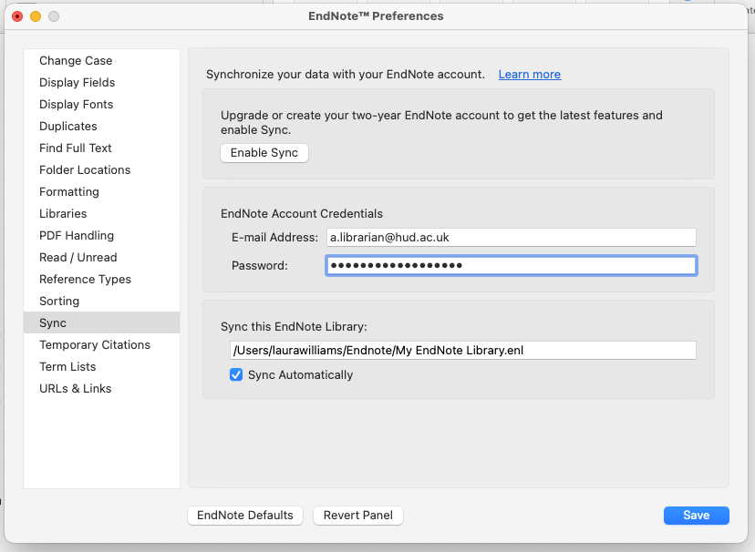
- Click on Sync from the left-hand menu.
- Type in the email and password you used for your EndNote Online account.
- Untick the Sync automatically box (we encourage you do this manually, every time you log off, because if not the library regularly syncs to the cloud and can slow down the performance of EndNote.)
- Click Save to finish the set up.

Tips:
- We recommend syncing your account every time you launch EndNote Desktop, and again when you have finished working with it. This will ensure you are working with the most up-to-date version of your library at the start of each session, and that you save any changes at the end.
- To sync manually, click on Library from the top toolbar and select Sync.
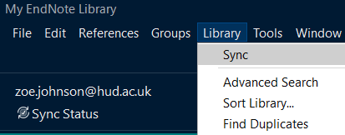

- You can see when you last synced by clicking on Sync Status on the left-hand side.
- If you cannot install software on your own device, or prefer to work online, you can use EndNote Online as a standalone, web-based app. See our EndNote Online workbook for instructions on using this similar, but different interface.

3.2 Importing references into your Library
There are many ways of importing references into your Library. We recommend clicking on the arrow to the left of ONLINE SEARCH to close it. This option is not configured to work with University of Huddersfield systems. We will show you more productive ways of importing references.
We will start with Summon, as the University of Huddersfield’s catalogue of owned print and electronic resources.

Exercise 1: Adding references from Summon
- Make sure an EndNote library is open, minimise the screen. Open Summon (you will always find a link to Summon on the University web pages or MyHud).
- Perform a search in Summon and save at least 3 books and 3 journal articles by clicking on the save this item icon on the right-hand side so it changes colour.
- After saving a number of results click on the saved items folder in the top right-hand corner and a list of all items saved will be displayed.
- From the Export To... drop down menu choose EndNote.
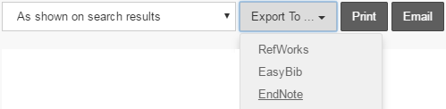

- A file download box will appear (this may appear in different places, e.g. at the bottom of the screen or as a pop-up, depending on what browser you are using). Double click to open the file in EndNote.
- EndNote will automatically re-open and you will see the imported references in your Library.
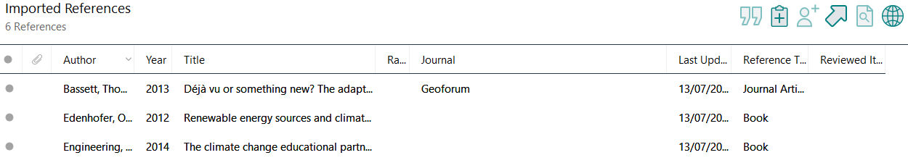
Tip
- If you are searching Summon again, remember to clear any saved items, to avoid sending duplicate references to EndNote in the same session.

Exercise 2: Adding references from Scopus
The next exercise demonstrates exporting from Scopus, which is a key multi-disciplinary resource available at Huddersfield. For help with exporting from other resources (see full list ), contact your subject librarian.
- Return to the Summon homepage and type Scopus into the search box.
- Select the link to Scopus.

- If prompted to log in, use your university username and password.
- Do a search in Scopus and click in the boxes next to the relevant title to select 6 items to export.
- Click on Export from the top menu.
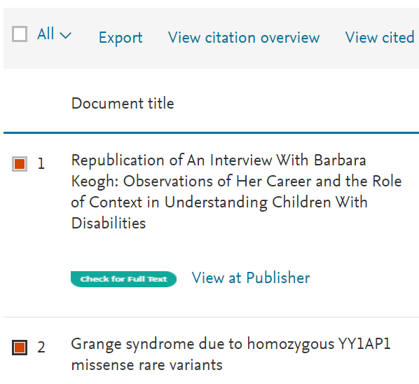

- Select RIS format and Abstract & keywords then Export.

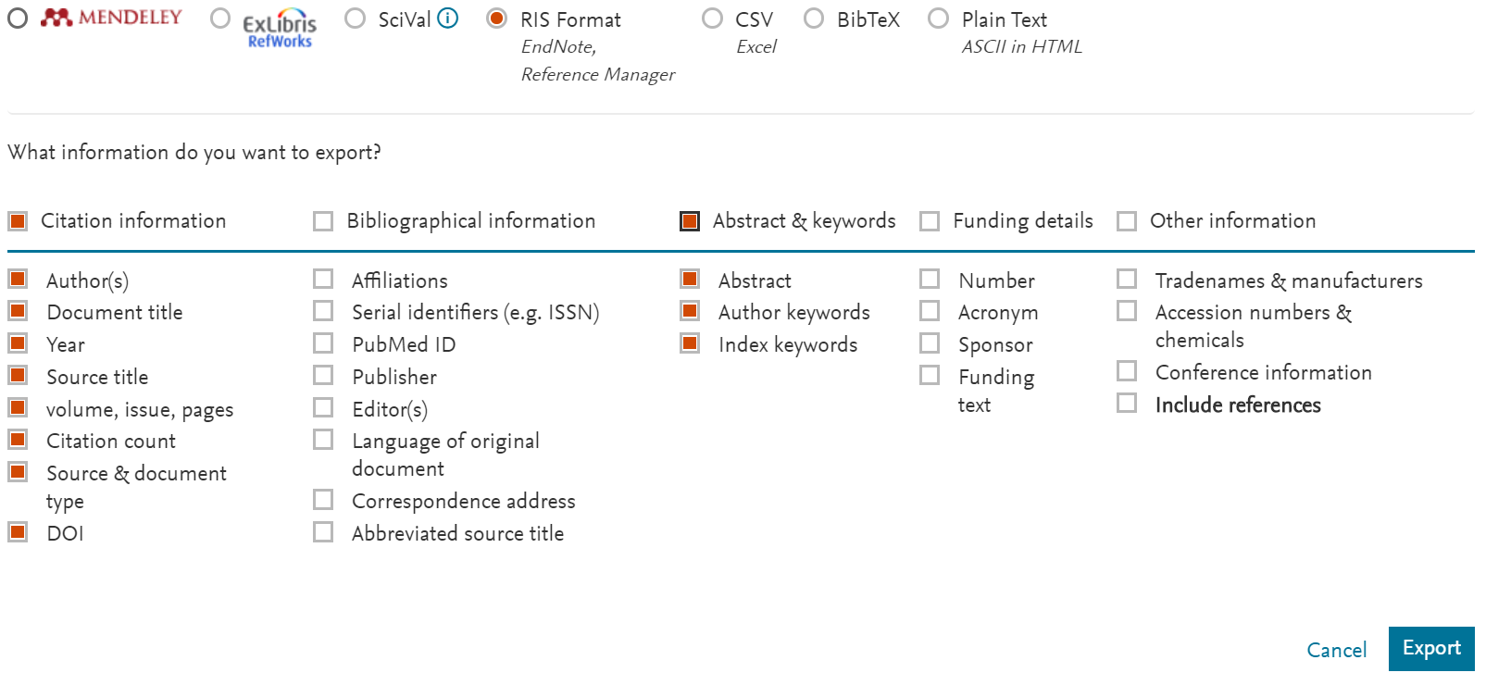

- A file download box will appear (this may appear in different places, depending on which browser you are using). Double click to open the file in EndNote.
- EndNote will automatically re-open and you will see the imported references in your Library.

3.3 Amending and manually adding references
It is important to proof-read all imported references, as there can be missing data or errors in the original input process.
To amend a reference in your library, click on the item you want to edit. The right-hand panel will display the full detail, click on Edit at the top of this panel. The various fields are then visible to edit.
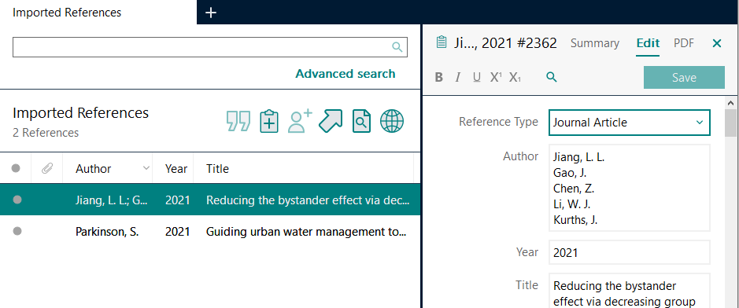

Some fields may turn red (author and journal) to indicate this is the first instance of that name. This helps ensure consistency of name spellings, e.g. Khan, S. K. could also be listed Khan, Sudheer or Khan, S.
You can scroll down to the Research notes field and add your own comments/ tags if you wish. These are then searchable in EndNote.
Once you have edited the reference, click on Save button at the top of the panel.

3.4 Manually add a reference
Sometimes you might have a reference you cannot locate in Summon or Scopus, e.g. a website, a live performance or a printed leaflet. EndNote has a number of templates from which to choose.

Exercise 4: Manually adding a reference
- To manually add a new reference to your library either click the button or select References and click New Reference (Control + N shortcut) from the toolbar.
- A pop-up window will appear with a blank template to manually type in the reference information to each of the fields. You can use as much or as little detail as you want.
- The default type is Journal Article. For this exercise, choose Web Page from the Reference Type drop down box.
- Complete the template with the following details:
  - Author: The Climate Coalition,
(this may appear in red, see tip below)
  - Title: This report comes with a health warning
  - Year: 2021
  - URL: https://www.theclimatecoalition.org/health-report
(NB. You will need to scroll down in the template to find the URL field).
- Click on File then Save from the top menu.
- Close this reference by clicking on the small x in the top right-hand corner of the box.

Tips:
- If there is more than one author, use the return key between author names.
- Authors can be entered in the format Anjum, F. M. or Faqir Muhammad Anjum.
- Organisations’ names must be followed by a comma e.g. Department of Health, otherwise EndNote will assume the last word is an author’s surname and your citations will appear as (Health, 2005) instead of (Department of Health, 2005).
- Red text indicates a name which has not been entered into a particular EndNote library before.
- You need to enter your references in the case in which you want the citations to appear (e.g. Bloggs, Jo C. not BLOGGS, JO C., or bloggs, jo c.).
- A digital object identifier (DOI) is used to uniquely identify an object such as an electronic document. APA 7th (the University approved referencing system) requires a DOI to be added to a journal article reference if available.

Section 4: Changing a referencing style
EndNote has a wide range of referencing styles to choose from, and the default is usually set to Annotated. The university’s approved standard is APA 7th, compiled by the American Psychological Association. Some taught courses may use a different style, please check with your lecturer if unsure. If you are a postgraduate researcher you may choose any referencing style, in agreement with your supervisor.

Exercise 5: Change reference style to APA 7th
- Double click on any reference to view the side panel.
- Check you are in the Summary tab.

- Underneath the reference details you will see another box you can maximise by clicking on the upward arrow.

- Select APA 7th from the first box. You can choose Select another style if this or your preferred style does not appear in the list.
- Click on the arrow to enlarge the box and see a preview of the reference.
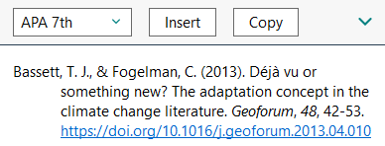

Section 5: Using groups to organise references
EndNote has a feature called groups to help organise references. You can organise by topic, thesis chapter or assignment/module, as you prefer.

Exercise 6: Creating groups
- Click on Groups then Create Group from the top menu. Alternatively, you can right click on My Groups in the left-hand menu.
- Double click on the New Group and rename it as appropriate.
- Add a second group in the same way.
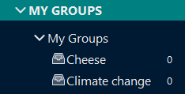
- You can then either drag each reference into the group or right click on the reference and select Add References To and then select the relevant Group.
Tips:
- The same reference can belong to more than one group.
- You can still see All References by clicking on the option at the top of the left-hand pane.
- Smart groups allow you to automatically add references to a group if they meet a specific criterion, e.g. a keyword or author name. This option is access from the Groups menu on the top toolbar.

Section 6: Using EndNote and Word
In addition to storing and managing your references, EndNote allows you to automatically insert in-text citations and create a bibliography in Word.
When EndNote is installed, a toolbar is added to Word which allows ‘Cite While You Write’ to be used to cite references from EndNote in Word documents.

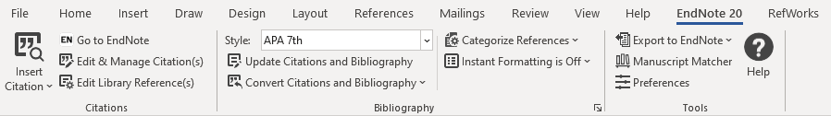

6.1 Adding citations and formatting a bibliography

Exercise 7: Adding citations and formatting a bibliography in Word
- Minimise your EndNote library and open Word. Type a few sentences into the document – just make something up!
- Click the EndNote 20 tab in the Word toolbar.
- Choose a point in your text where you wish to add a reference.
- Click on Insert Citation from the EndNote toolbar and select the first Insert Citation option.
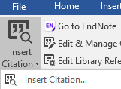

- Type the letter a in the search box and click on Find. This will show a list of ALL references you have in your open EndNote library.
- Click on the reference you wish to add to your Word document then Insert.
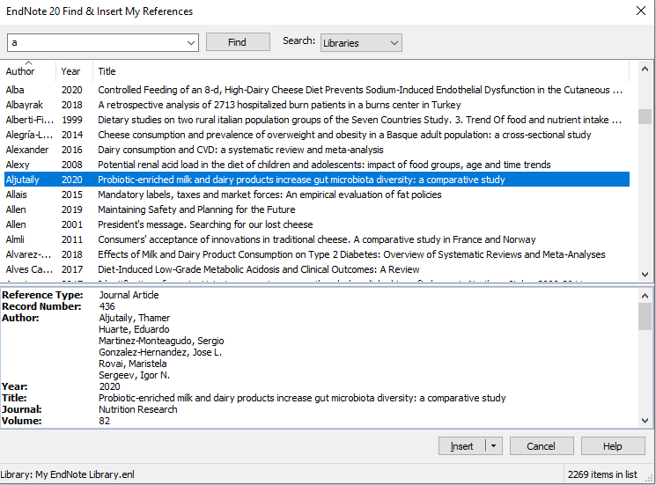

- The reference you selected should automatically be inserted into your Word document (as a citation) and the full reference will be towards the bottom of the page (starting a bibliography).

Tips:
- Instead of typing “a” for all citations, you can search by author/ keyword to find the relevant citation.
- After you highlight your reference, you can use the drop down menu next to insert different parts of the citation as preferred.
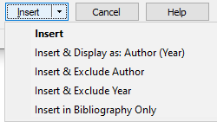
- Alternatively you can return to your EndNote library, highlight the reference/s you want to insert and return to Word to select Insert Selected Citation (s).
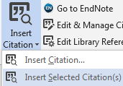

6.2: Editing citations in Word
Once citations have been added to your Word document you may wish to edit them. You may need to include page numbers (for example if you have used a direct quote), or you might want to exclude the author (for example when the author’s name appears as part of the sentence, e.g. “Jones (2013, p.5) suggests that…”).
This can be done using the Edit & Manage Citation(s) option in the EndNote ribbon of Word.
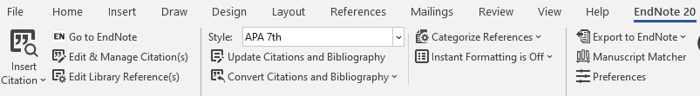

Exercise 8a: Adding page numbers to your citation
- Highlight the citation (it will appear greyed out), and on the EndNote 20 tab in Word click on Edit & Manage Citation(s).
- A pop-up box will appear, enter the page number in the Pages: section (if you want to add multiple pages use a hyphen between numbers, e.g. 5-7).
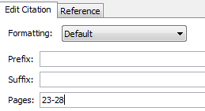

Exercise 8b: Excluding author/year from your citation
- Highlight the citation (it will appear greyed out) and on the EndNote 20 tab in Word click on Edit & Manage Citation(s).
- A pop-up box will appear, click on the Formatting: drop down menu. From here select the option you want to apply to the citation:
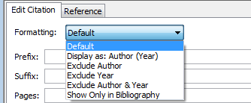
- Click OK and the citation will automatically change to exclude author OR year as selected.

Tips:
- The author/year is just hidden and can be retrieved by highlighting the citation, clicking on Edit & Manage Citation(s) and selecting the Default option.
- As well as changing the referencing style within your EndNote library, you can also change the style within your Word document (this will not affect the style in EndNote).
- In Word, place your cursor at the beginning of the text and select the EndNote tab.
- Click on the drop down arrow next to Style and Select Another Style…

Section 7: Managing PDFs and attachments in EndNote
There are various ways of managing PDFs/ file attachments within EndNote. There are three main options, depending on where you are in the research process.

Exercise 9a: Downloading a PDF into EndNote
After you have downloaded a journal article reference into your Library, you can use EndNote to locate the PDF of the full text through the Library’s electronic journal subscriptions.
- In the top menu click on the Find Full Text icon . EndNote will search the University of Huddersfield’s subscriptions and pull in the full text PDF, if possible.
- You may be asked to log in with your university log in and password. Then click on Continue (twice) and the box will disappear.
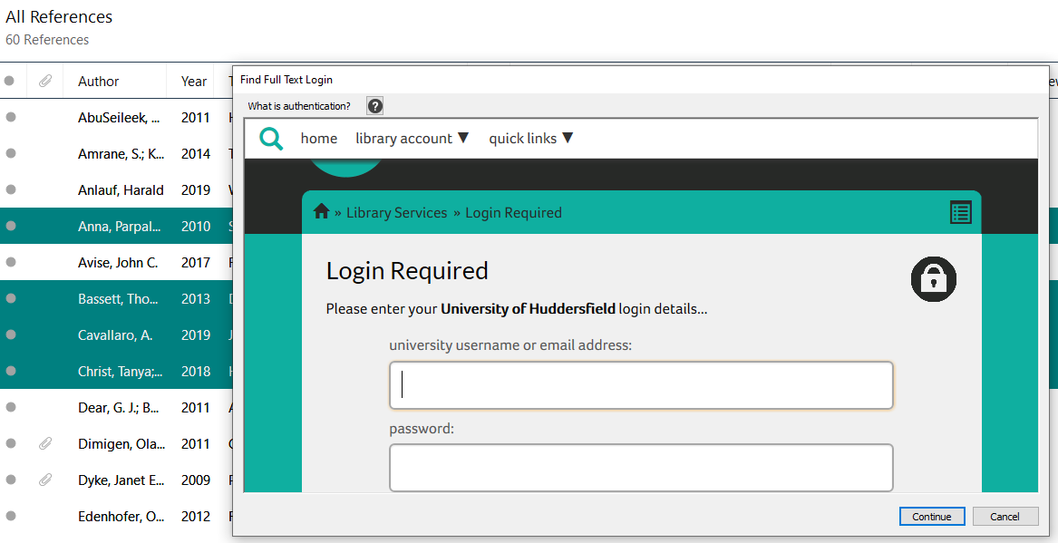
- Click on OK and EndNote will start searching for matches.
- You can check the success rate on the left column and the PDFs will be attached (see paper clip icon) to the relevant records.
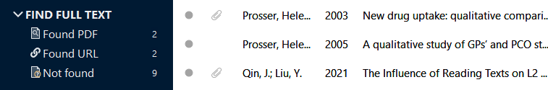

- This method may not find every full-text PDF available. Success rates vary depending various factors, including the age of the paper. You may need to download the PDF from the journal site and follow the next exercise to link it to the EndNote reference.

Exercise 9b: Adding a PDF to a reference
If you have downloaded a journal article reference into your Library, and you also have the PDF of the article saved, you can attach this to the record in EndNote. To link and save the PDF into your EndNote library:
- Double click on the reference in your EndNote library to which you want to attach the PDF.
- From the Summary tab on the right-hand side, click on Attach file.
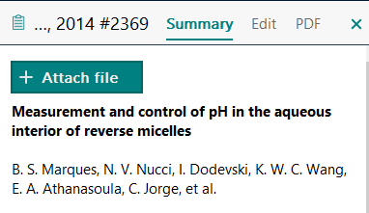

- A pop-up box will open so you can locate the PDF on your computer/ device.
- Click on Open and the PDF should now appear above the title of your reference, in the right-hand section of your EndNote library. You can add multiple files if required.
- To save the changes, simply click on another reference and EndNote will prompt you to save.

Exercise 9c: Extract reference from existing PDF
If you have already downloaded the PDF of the full text on to your computer, you can add it to EndNote and import the reference at the same time. If you have already collated a lot of research, this exercise can save you time.

Windows instructions:
- Click on File, go to Import and select File (for one PDF) or Folder (for multiple PDFs).
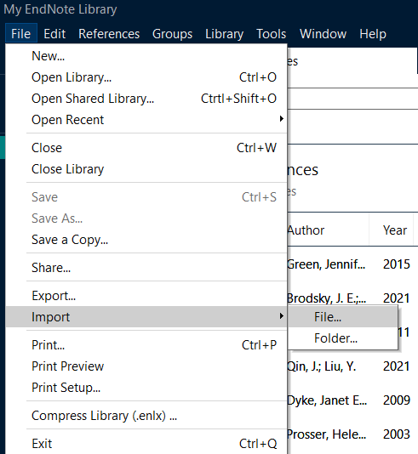

- Click Choose and then search for the file/s on your device which you want to save to EndNote.
- Check the Import Option is set to PDF and click on Import.
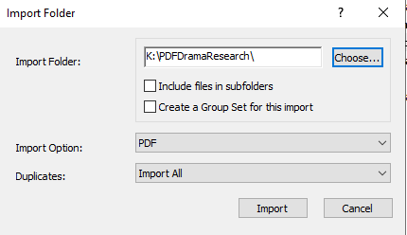

Mac instructions:
- Click on File, click on Import.
- Search for the file/s on your device which you want to save to EndNote.
- Click Options to select the format type for the file you want to import. Ensure this is set to PDF and click on Import.
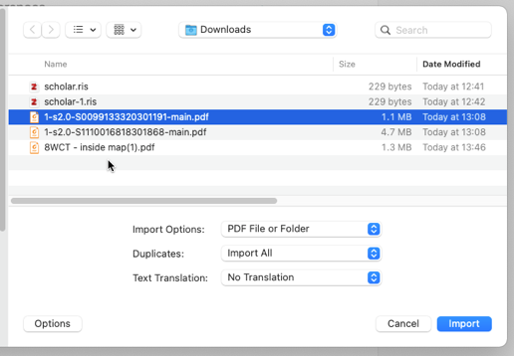

- EndNote will attempt to extract the information from the saved articles to create new references in your Library with the PDF attached (See Hubbard example below).
- If EndNote cannot extract the data (See Barkham2019 example below), you will need to manually add the reference details from the PDF. See Section 3.3 on amending references for help.

Tips:
- EndNote is compatible with most of the other electronic resources to which we subscribe, see the full list.
- You can also use it with Google Scholar although it does restrict you to importing one reference at a time. The quality of the reference will be varied, so ensure you check it for accuracy.
- For help with downloading from this and other resources, check each resource’s help pages or contact your Subject Librarian at library@hud.ac.uk

Section 9: Saving, backing up and moving your EndNote Library
We recommend you syncing your EndNote Library to EndNote Online every time you close down the desktop app. This ensures a back up on their cloud server, from which you sync to when moving between different computers (e.g. home to work device) or sharing a library with a fellow researcher.
If you do need to save or move your EndNote Library on to another device (e.g. USB stick, external drive or another computer), please remember there are two files to copy, which will have the name of your Library.
The .Data file contains any PDFs you have saved in the Library and also style changes you might make to the referencing styles.

Tips:
- EndNote libraries must not be saved on a cloud service, like OneDrive, Google Drive or Dropbox, as they are likely to get corrupted over time.
- However, backups of the library created via Tools/ Compressed Library can be stored on these services and this a good way to ensure you have a backup available at any time, should you need it.

Section 10: Where can I access EndNote?
The University holds a site licence for EndNote so it:
- is available on all University PCs.
- can be installed on any University-owned laptop on request.
- can be installed on your home computer. It is free for all current staff and students to download from the software purchasing page. The software download for Endnote 20 has download options for Windows and Mac. Please note that this EndNote license agreement is for academic use only, and you must uninstall the application when you graduate/leave employment of the University.
- before graduating, you could buy a student licence personal copy for further use from the EndNote site.

Section 11: Further help
We highly recommend using the Help section within EndNote as it is very comprehensive.
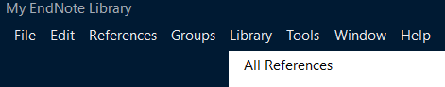

For further support, you can contact your Subject Librarian on library@hud.ac.uk

We also recommend the following websites:
- Our library web pages (including a link to this document).
- EndNote training videos (via supplier’s YouTube channel).
- EndNote user guide (from supplier).
- The EndNote website which includes a styles to download section offering 6,000 bibliographic styles.

This manual was last updated on 21 July 2023.

